Web VistA Remote Access Management (WebVRAM)

Administration Module User Guide



December 2019

Department of Veterans Affairs

Office of Information and Technology (OIT)

Revision History

| Date | Revision | Description | Author |
| --- | --- | --- | --- |
| 12/4/2019 | 1.7 | Updated to address comments from Health Product Support. Technical Writer review and edit. | WebVRAM Project Team, VA OIT Enterprise Program Management Office (EPMO) |
| 11/21/2019 | 1.6 | Added clarity to different pathways for Business Unit Administrator and WebVRAM Administrator to add new user. | WebVRAM PMO Support |
| 11/15/2019 | 1.5 | Changed title of Section 2.1 to WebVRAM Roles and defined all user roles. Changed “Business Administrator” to “Business Unit Administrator” to match the names of Roles in the application. Corrected various entries “Admin” or “Administrative” to Administration to match the wording displayed in the application for consistency. Changes to Section 3.5 include updates to instructions and narrative on adding user based on the user role (Business Unit Administrator or WebVRAM Administrator). | WebVRAM PMO Support |
| 10/18/2019 | 1.4 | Added instructions for entering required VistA Profile data. | WebVRAM PMO Support |
| 10/11/2019 | 1.3 | Technical Writer review and edit. | WebVRAM Project Team, VA OIT EPMO |
| 10/9/2019 | 1.2 | Added content for Home VistA View/Change and View Logs functionality. | WebVRAM PMO Support |
| 10/7/2019 | 1.1 | Reworked flow to match screen shots and added Duplicate User error process steps. | WebVRAM PMO Support |
| 9/25/2019 | 1.0 | Baseline document. | WebVRAM Project Team, VA OIT EPMO |

Table of Contents

1. Introduction 1

1.1. Purpose 1

1.2. Document Orientation 1

1.2.1. Organization of the Manual 1

1.2.2. Assumptions 2

1.2.3. Coordination 2

1.2.4. VA OIT Standard Disclaimers 2

1.2.4.1. Software Disclaimer 2

1.2.4.2. Documentation Disclaimer 2

1.2.5. Documentation Conventions 3

1.2.6. References and Resources 3

1.3. Enterprise Service Desk and Organizational Contacts 3

2. Software Summary 4

2.1. WebVRAM Roles 4

3. Getting Started 5

3.1. Administrator User Setup 5

3.2. Information the Administrator User Will Need 5

3.3. Logging into the WebVRAM Administration Module (WAM) 6

4. Using the Application 10

4.1. View / Edit User 10

4.2. Add New User 15

4.3. Quick Delete of User Profile Entries 22

4.4. Duplicate Users in Home VistA 23

4.5. Viewing/Editing User’s Home VistA System/Name 26

4.6. View User’s Log 29

4.7. Disabling User Account 31

4.8. Exit System 31

5. Troubleshooting 32

5.1. Special Instructions for Error Correction 32

6. Acronyms and Abbreviations 33

List of Figures

Figure 1: WebVRAM Terms and Conditions for Usage Screen 6

Figure 2: WebVRAM Login Screen 7

Figure 3: WebVRAM Main Screen 8

Figure 4: WebVRAM Administration Module Main Page 9

Figure 5: WebVRAM Administration Module Users Page 10

Figure 6: WebVRAM Administration Module Edit User Screen 11

Figure 7: WebVRAM Administration Module VistA Sites 12

Figure 8: WebVRAM Administration Module User Selection 13

Figure 9: Add/Remove Secondary Menu Options Screen 14

Figure 10: Users / Business Unit Screen Selection Screen 15

Figure 11: Business Unit Screen 15

Figure 12: WebVRAM Administration Module Add User Screen 16

Figure 13: User Lookup on Add User Screen 16

Figure 14: User Not Found on Home VistA Error 17

Figure 15: User Lookup on Add User Screen 18

Figure 16: VistA Profile Option 20

Figure 17: VistA Profile Data Entry Fields 21

Figure 18: Edit User Quick Delete Option 22

Figure 19: Duplicate User Error Message 23

Figure 20: WebVRAM Access Request Screen 24

Figure 21: User Disabled Status 24

Figure 22: WebVRAM User Screen with Enable User Button 25

Figure 23: WebVRAM Edit User Screen – Edit User Option 26

Figure 24: User Key Data Edit Page 27

Figure 25: User Key Data Page – Home VistA Box Cleared 27

Figure 26: User Key Data Page – Home VistA “Auto-Fill” Feature 28

Figure 27: User Key Data Page –New Home VistA System Selected 28

Figure 28: User Edit Screen – View Logs Button 29

Figure 29: User Log Listing 29

Figure 30: User Log Detail Listing 30

Figure 31: Edit User Screen – Disable User Button 31

List of Tables

Table 1: Documentation Symbols and Descriptions 3

Table 2: Enterprise Service Desk Support Information 3

Table 3: Acronyms and Abbreviations 33

# Introduction

The Web VistA Remote Access Management (WebVRAM) application solution enables synchronization of VistA account credentials by leveraging the VistA Station ID Callback (STIC) module at user login while maintaining an internal user table that can be electronically populated with user profiles, VistA menus, and keys. With the cloud-hosted application, users of WebVRAM will enjoy consistency in access to disparate VistA systems.

In April 2019, the WebVRAM Office of Information and Technology (OIT) management determined that user authentication for the application needed to be performed internal to the application itself, rather than utilizing an external authentication service. A redesign of the software became necessary and includes provision for a new WebVRAM User Table (WUT) to be retained in a Structured Query Language (SQL) database. To enter authorized application user profiles into the WUT, an Administration (Admin) Module Graphical User Interface (GUI) has been developed.

## Purpose

The purpose of the WebVRAM Administration Module User Guide is to familiarize authorized users of the Administration Module (not the WebVRAM application) with the key features and navigational elements of the GUI. Additionally, this guide provides technical information to system administrators, IT support staff, and other authorized WebVRAM Administration Module users. The Administration Module GUI will be used to add new, business-authorized users of the WebVRAM application to the WUT. Adding new users will consist of entering a user profile via the GUI to create user data in the WUT. The WUT user profile allows the WebVRAM application user to login and access its functionality. A separate user guide exists for users of the WebVRAM application.

## Document Orientation

The document orientation is shown below in Sections 1.2.1 through 1.2.6.

### Organization of the Manual

The major sections of the WebVRAM Administration Module User Guide are as follows:

1. Introduction
2. Software Summary
3. Getting Started
4. Using the Application
5. Troubleshooting
6. Acronyms and Abbreviations

The target audience for this guide includes authorized users, system administrators, and IT support staff.

### Assumptions

This guide was written with assumptions as follows:

* WebVRAM Administration Module users are authorized by business line management to access the GUI for the purpose of recording user profiles in the WUT.
* User profile information for users of the WebVRAM application is provided by the user’s business line management to those responsible for entering that user profile data through the Administration Module.
* Required local Security Keys are identified and incorporated into User Account Profiles by WebVRAM Administration Module users.
* Users of the WebVRAM application have current VA network access and an active local or “home” VistA user profile. WebVRAM application users must also arrange to have the WEBG WEBVRAM GUI Secondary Menu Option added to their VistA profile.

Triangle with an exclamation point (!) inside to indicate caution for the reader to take special notice of critical information.**IMPORTANT: The WEBG WEBVRAM GUI Secondary Menu Option is required for the user to be able to login to the WebVRAM application.**

* The primary menu option at the user’s Home VistA system is a standard VistA menu name (not a custom menu name).
* Administration Module users will only be responsible for entering application user profile data and will not be responsible for any WUT maintenance or WebVRAM application maintenance.

### Coordination

WebVRAM Administration Module users must obtain approval from their respective WebVRAM application business owners/stakeholders to access and use the WebVRAM Administration Module to enter application user profile data into the WUT.

### VA OIT Standard Disclaimers

#### Software Disclaimer

This software was developed at the Department of Veterans Affairs (VA) by employees of the Federal Government in the course of their official duties. Pursuant to title 17 Section 105 of the United States Code, this software is not subject to copyright protection and is in the public domain. VA assumes no responsibility whatsoever for its use by other parties, and makes no guarantees, expressed or implied, about its quality, reliability, or any other characteristic. We would appreciate acknowledgement if the software is used. This software can be redistributed and/or modified freely if any derivative works bear some notice that they are derived from it, and any modified versions bear some notice that they have been modified.

#### Documentation Disclaimer

The appearance of external hyperlink references in this manual does not constitute endorsement by the Department of Veterans Affairs of this website or the information, products, or services contained therein. The VA does not exercise any editorial control over the information you may find at these locations. Such links are provided and are consistent with the stated purpose of the VA.

### Documentation Conventions

This manual uses several methods to highlight different aspects of the material.

Various symbols are used throughout the documentation to alert the reader to special information. The table below gives a description of each of these symbols.

Table 1: Documentation Symbols and Descriptions

| Symbol | Description |
| --- | --- |
| Symbol for additional information (letter "i") inside a circle. | **NOTE:** Used to inform the reader of general information including references to additional reading material. |
| Triangle with an exclamation point (!) inside to indicate caution for the reader to take special notice of critical information. | **CAUTION:** Used to caution the reader to take special notice of critical information. |

“Snapshots” of computer online displays (i.e., character-based screen captures/dialogs) and computer source code are shown in a non-proportional font and enclosed within a box. Also included are GUI Microsoft Windows images (i.e., dialogs or forms).

User's responses to online prompts (e.g., manual entry, taps, clicks, etc.) will be shown in **boldface type**.

### References and Resources

* WebVRAM System Design Document
* WebVRAM Requirement Elaboration Document
* WebVRAM User Stories and Backlog – Rational Repository

## Enterprise Service Desk and Organizational Contacts

Enterprise Service Desk (ESD) support information is provided in the table below.

Table 2: Enterprise Service Desk Support Information

| Name | Role | Org | Contact Info |
| --- | --- | --- | --- |
| OIT Enterprise Service Desk | Tier 1 Support | OIT | 1-855-673-4357 or Teletypewriter (TTY) 844-224-6186; [nationalservicedeskanr@va.gov](mailto:nationalservicedeskanr@va.gov) |
| OIT Enterprise Service Desk | Tier 2 Support | OIT | Tier 1 ESD will escalate tickets to Tier 2 Support as required for issue resolution. |
| OIT Enterprise Service Desk | Tier 3 Application Support | OIT | Tier 2 Support will escalate tickets to Tier 3 Support as required for issue resolution. |

# Software Summary

WebVRAM is a web-based, cloud-hosted application utilizing VA Enterprise Architecture and Design principles that facilitates user access to multiple remote VistA systems and related applications such as Computerized Patient Record System (CPRS) and the Fee Basis Claim System (FBCS), without requiring the user to establish login authentication and credentials at each VistA where Veteran data is to be viewed. The need for multiple VistA sessions, with separate user profile login to each VistA instance, is eliminated.

Application features are provided through a GUI. The VA-approved web browser for accessing WebVRAM is Microsoft Internet Explorer (IE) version 11.0.

## WebVRAM Roles

The WebVRAM Administration Module enables the management of users, profiles, assignment of users to business units, and report generation. There are three types of user roles:

* **WebVRAM User** – The WebVRAM User can only access designated remote VistA sites; the WebVRAM user can launch a remote session using Launch Reflection or Launch CPRS from the main page of the application. The WebVRAM user does not have access to the WebVRAM Administration Module.
* **Business Unit Administrator** – The Business Unit Administrator has access to the WebVRAM Administration Module pages and can manage users within their assigned business unit. The Business Unit Administrator can create and add new users for the business unit to which they are assigned to manage and can only view/edit users within their business unit.
* **WebVRAM Administrator** – The WebVRAM Administrator has access to the WebVRAM Administration Module pages and has the highest user-level role. The WebVRAM Administrator can add new business units and can assign Business Unit Administrators to a business unit. The WebVRAM Administrator can create, view and edit users and business units, view log files, and pull reports sorted by business unit. WebVRAM Administrator is the highest access level.

# Getting Started

## Administrator User Setup

To access the WebVRAM Administration Module (WAM), the user follows these initial process steps:

1. The business unit determines and implements their process for approving users to access WebVRAM and determines which VistA remote sites they can access.
2. The business unit approves and designates one or more Business Unit Administrators authorized to add new users to the WebVRAM User Table (WUT).
3. A WebVRAM Administrator adds the Business Unit Administrator(s) to the WUT database and specifies which business unit with which they are associated. Each business unit determines whether there are divisions that can be added as a business unit within the larger organization.

## Information the Administrator User Will Need

* Windows VA Username from the Global Address List (GAL) (e.g., vhaisl….)
* Home VistA system name(s) (e.g., Togus, ME; Connecticut HCS; etc.)
* VistA systems the user is authorized to access by their business line management
* Additional setup items required for correctly setting up a new user for access to WebVRAM:
  + User’s Home VistA System Primary Menu
  + User’s Home VistA System Secondary Menus
  + User’s VistA Security Keys
  + User’s VistA Title (from Home VistA user profile)
  + User’s VistA User Class and Person Class

Caution symbol **IMPORTANT: The user will be required to request the WEBG WEBVRAM GUI Secondary Menu option be added to their local VistA user profile before they can be added to the WebVRAM User Table database. Without that menu option, they will not be able to login to the WebVRAM application.**

## Logging into the WebVRAM Administration Module (WAM)

1. From your Internet Explorer browser, navigate to the WebVRAM home page at this link: <https://WebVRAM.va.gov/>
2. The Terms and Conditions web page will be the first page displayed. Read through the conditions and click **Accept the Terms and Conditions** as shown below.

Figure : WebVRAM Terms and Conditions for Usage Screen

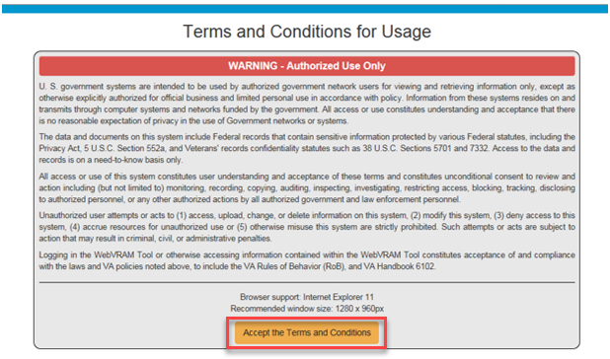

1. The next web page displayed is the WebVRAM Login page. Enter your local VistA Access and Verify Codes and click **Login** to access the application features.

Figure : WebVRAM Login Screen

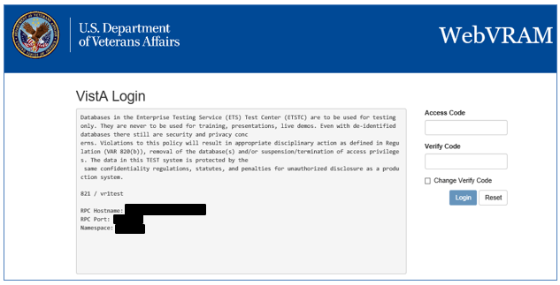

1. The WebVRAM application’s main page is displayed. Click on **Manage** from the menu bar along the top of the page.

Figure : WebVRAM Main Screen

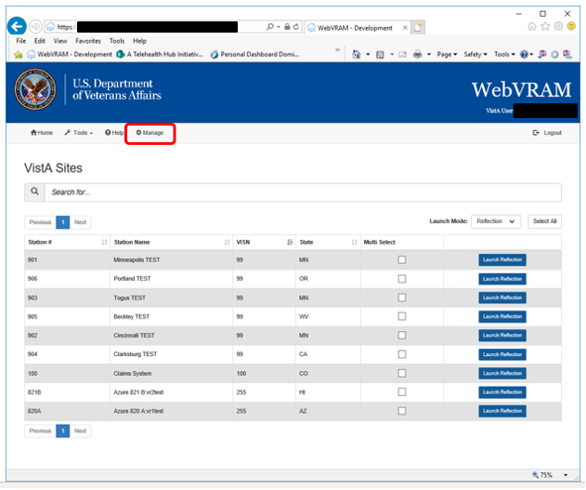

1. The WebVRAM Administration Module main page is displayed.

Figure : WebVRAM Administration Module Main Page

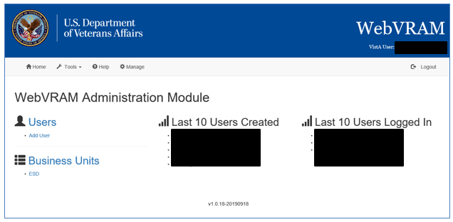

# Using the Application

## View / Edit User

1. **Find User:** In many instances, the user will have recently requested a change to their existing WebVRAM User Profile. When a WebVRAM Administrator or a Business Unit Administrator user logs in to the WAM, they will be shown a display of the last 10 users to login to the system and may be able to select the user they need to edit. If the user is not in that list, click on the **Users** link on the left side of the Main Page as shown in Figure 4: WebVRAM Administration Module Main Page. Clicking that link displays the Users Page as shown in Figure 5: WebVRAM Administration Module Users Page. Clicking on the **Next** button or the **page number** at the bottom of the screen will allow you to scroll through the user list. Or, you may click on the **Last Name** or **First Name** heading to sort the list alphabetically.

Figure : WebVRAM Administration Module Users Page

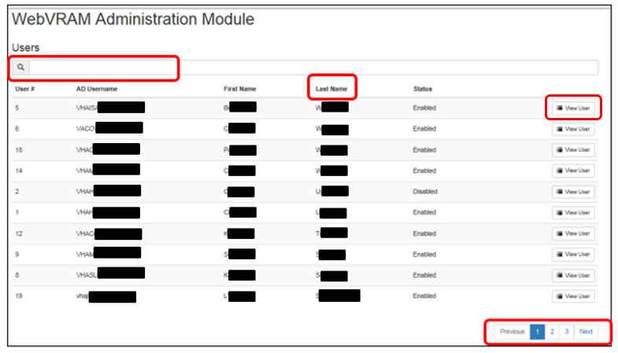

1. **Search Box:** In the box with the magnifying glass icon above the Users list, type the user’s last name, or first name <space> last name, or Windows VA Username/Network ID. Windows VA Username may be the best search option to prevent seeing multiple users with the same or similar name. This search will start showing names of users matching the search criteria entered so that the correct user can be selected to edit.
2. **View User:** Once the user is identified, to edit the user, click on **View** **User** on the right side of the user’s name as shown in Figure 5 above. This opens the Administration Module **User** screen, which provides an overview of the data elements that can be added or removed from a user’s profile as shown in Figure 6: WebVRAM Administration Module Edit User Screen. To add information for any given component, click on the “**+**” sign in each area. From this screen, user information listed here can be added or removed from the user profile.

Sections include:

* VistA Sites (remote VistA sites a user has been authorized to access)
* CPRS tabs
* Secondary Menu Options
* Security Keys
* Person Classes
* User Classes
* WebVRAM Roles – the roles the user will have in relation to the use of WebVRAM
* WebVRAM Business Units – assigning a Business Unit to the user
* VistA Profile

Figure : WebVRAM Administration Module Edit User Screen

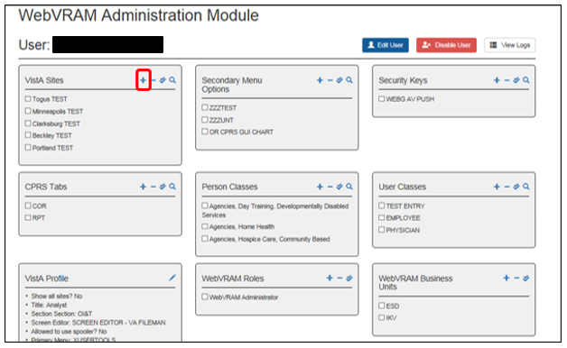

1. Clicking on the “**+**” sign in the VistA Sites box brings up the next screen, which displays remote VistA systems the user is approved to connect to for work.

Figure : WebVRAM Administration Module VistA Sites

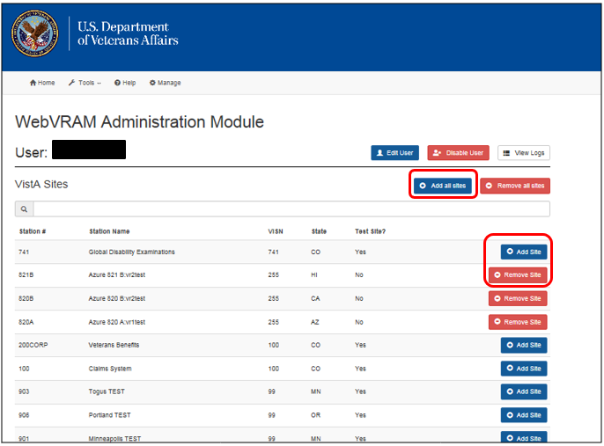

1. **Add/Remove VistA System(s) Selection Screen**: VistA sites approved by the user’s manager can be added to the user’s profile in this screen by clicking the **Add Site** button on the right side of the row corresponding to the VistA location. Sites can be removed from the user’s profile by clicking the **Remove Site** button on right side of the line of the site to be removed. If authorized, ALL VistA sites can be added to the user’s profile by clicking the **Add all sites** button. Once all sites are added to the user’s profile, selected VistA sites can be removed by searching for them using the search window, and then clicking on **Remove Site**.
2. **Additional Edits**: After one area is edited for the user, to edit other components of that user, click on the user’s name at the top of the User page as shown in Figure 7 above, and the Edit User screen will be shown again as seen in Figure 6. Select the component to edit and click the “**+**” sign to add or remove data.

Figure : WebVRAM Administration Module User Selection

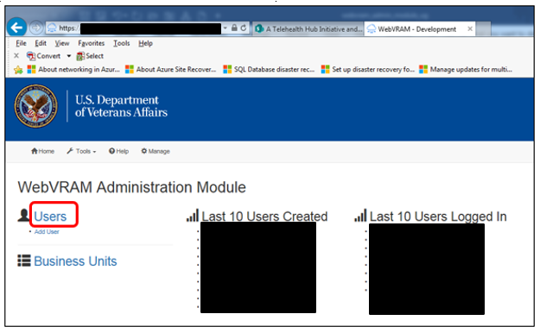

1. Clicking on the **Users** link on the left side will open a longer user list displayed on a new page as shown above in Figure 5: WebVRAM Administration Module Users Page. You can also search for a user by entering a partial name in the search window.
2. **Updating the User Profile**: Edits to each area of the user profile can be performed by following a similar process for each component as shown in Figure 7 and here in Figure 9. To add an option, click the **Add <Option>**button on the right side of the option. To remove an option, click the **Remove <Option>** button on the right side if an option was added in error.

Figure : Add/Remove Secondary Menu Options Screen

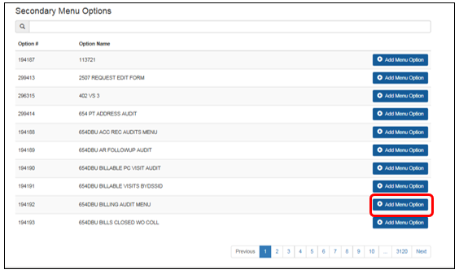

## Add New User

The Business Unit Administrator can add new users to the Business Unit they are authorized to manage. To add a new user, click **Manage** on the toolbar. Under the **Business Units** heading, click on the **Business Unit abbreviation** and then click on **Add User** on the right side of the screen. See Figure 10 and Figure 11 below. After selecting these options, the “Add User”page is displayed.

Figure : Users / Business Unit Screen Selection Screen

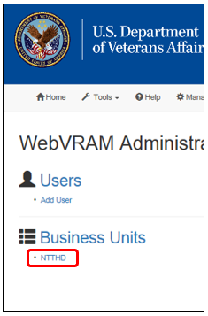

Figure : Business Unit Screen

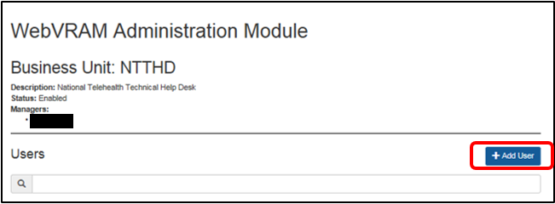

The WebVRAM Administrator can add a user as outlined above using the “Business Unit” pathway, or they can simply click on the **Add User** link under the **Users** heading on the same page. The “Add User” page is displayed, as shown in Figure 12 below.

Figure : WebVRAM Administration Module Add User Screen

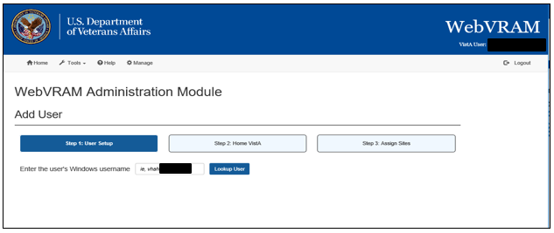

1. **Windows Username Search Box**: Search for a user to add to the WUT by typing their full Windows VA Username/Network ID in the **Enter the user’s Windows username** search box and clicking on the **Lookup User**button.
   1. If the user is found in the VA GAL/AD, the user’s full name is returned and presented on the screen with a message prefix of “Active Directory Found (First, Last Name:)” as shown below.

Figure : User Lookup on Add User Screen

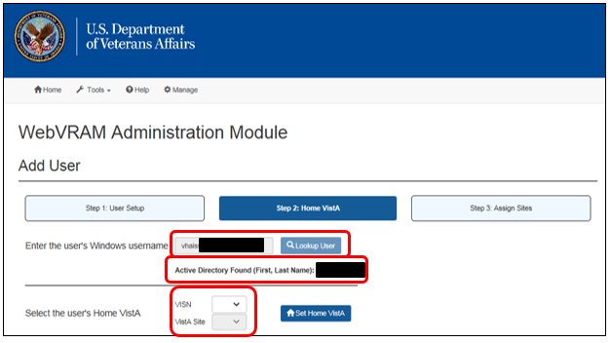

1. Verify the user found is the correct user. If so, select the user’s VISN and associated “Home” VistA Site from the drop-down lists shown in Figure 7. If the user already exists in the WebVRAM User Table, the Edit User screen will automatically appear as shown in Figure 6.
2. If the user does not have an active VistA account at the Home VistA Site selected, an error will appear indicating the user was not found on that VistA system. Unless the site was selected incorrectly, you will need to contact the user to confirm that they have an active VistA account and user profile established on their Home VistA system.

Figure : User Not Found on Home VistA Error

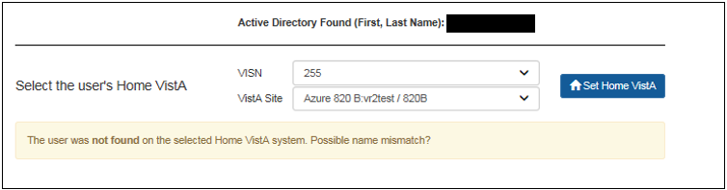

1. Once the Home VistA system is selected from the drop-down boxes, click the **Set Home Vista** button. If all user profile information is entered correctly in the user’s Home VistA system, a “Success” message will display, as shown in Figure 15 below, and you can then add authorized VistA sites to the user profile by clicking on the **Add VistA Sites** button.

Alternatively, the Administrator may choose to add another user at this point without first updating the VistA sites for this user, if the Administrator prefers to add all users first and update their profile information later. To proceed in this manner, click the **Add another user** button.

Figure : User Lookup on Add User Screen

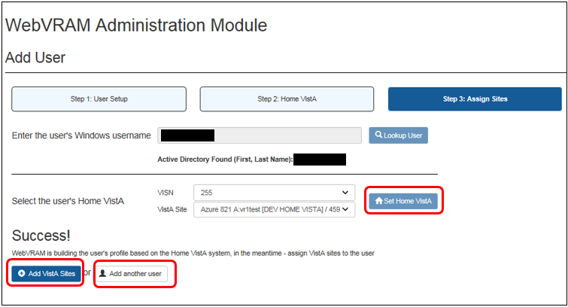

1. As shown in Figure 6, the following data elements should be added to each new user profile once the user has been added to the WUT, ***if the VistA profile of the user is not accessible to the WebVRAM application for automatic retrieval of this data*:**

* **VistA Sites (Remote)** – Add all VistA sites the user is approved to access to perform work. As shown in Figure 7, the user can have ALL VistA systems added to their profile if they are authorized to access all VistA sites across the VA enterprise.
* **CPRS Tabs** – CPRS users will need the **COR** and **RPT** tabs added to their profile.
* **Secondary Menu Option** – Add any Secondary Menu Options required to use VistA applications when the user connects to remote VistA sites. For example, the CPRS application requires the user to have the **OR CPRS GUI CHART** Secondary Menu option in their user profile before CPRS can be launched.
* **Security Keys** – The **WEBG AV PUSH** security key MUST be added to the WebVRAM user profile. If not present, the user will not be able to completely synchronize to a remote VistA system, and when attempting to launch CPRS at a remote site, the user will receive an “Invalid Access/Verify Code Pair” error.

Add other security keys that exist in the user’s VistA profile as needed. Also add security keys for site-specific applications that only exist at one or a few remote VistA sites if the user will need these keys to perform job responsibilities at those sites.

* **WebVRAM Roles** – Add the **WebVRAM User** role to the user’s profile.
* **WebVRAM Business Units** – If this data element is not automatically populated, add the appropriate business unit to the user’s profile by opening this widget and clicking **Assign to User** on the right side of the business unit to be added.

1. **MANDATORY:** Select or add the following data elements to the user profile. These elements are mandatory, and if not added, will cause access to WebVRAM to fail or will cause certain features of WebVRAM to fail. They cannot be blank. To edit these fields, from the User Screen, click on the **pencil icon** in the top right corner of the **VistA Profile** box as shown in Figure 16. The data for each field to be selected/added is listed here and shown in Figure 17.

* **Title** – If not auto-populated, enter the user’s job title as recorded in their VistA profile, such as Nurse Practitioner, Benefits Clerk, Physician, Help Desk Technician, Psychiatrist, Analyst, etc.
* **Service Section** – If not auto-populated, enter the user’s VA Service Section, such as VHA, VACO, VBA, OIT, etc.
* **Screen Editor** – If not auto-populated, enter **SCREEN EDITOR – VA FILEMAN**. Some business units, such as Consolidated Patient Account Center (CPAC), use a different screen editor to perform job functions. Check with each user to verify the screen editor they should use.
* **Allowed to use spooler?** – Most users will not need to use the VistA spooler. Each business unit will need to determine which users require the spooler. The default value for this option is **No**. For users who need this VistA feature, select **Yes** from the drop-down menu.
* **Primary Menu** – If not auto-populated, ask the user to supply the name of their primary menu; the user may have to contact their local IT support staff to find out their primary menu. Once known, enter the user’s VistA Primary Menu name. This value must be a standard VistA menu name for the user’s primary menu on his/her local or Home VistA system.

Caution symbol**CAUTION: If the primary menu is not a standard VistA menu, the user will not be able to connect to remote VistA systems through WebVRAM; the connection will fail with a “menu tree rebuild failure” error**. Menu names that start with **ZZ**, such as **ZZ CLINICIAN MAIN MENU**, are not VA standard menus and should not be entered in this field. If the user’s primary menu is a custom menu, have the user submit a Service Now (SNOW)/YourIT ticket to the Enterprise Service Desk to request the name of the closest VA standard menu to the user’s custom menu and have it assigned as the primary menu on the user’s Home VistA system. This value is passed to the VistA remote sites to which the user has access and becomes the primary menu at the remote sites after synchronization and login through WebVRAM.

After all edits have been made to the fields in this category, click the **Update VistA Profile** button at the bottom of the window. If updates should not be saved, click **Cancel**.

**NOTE:** Other options of the user profile should be updated automatically when the user logs in to the WebVRAM application for the first time. Upon initial login, WebVRAM checks the user’s Home VistA system and retrieves all keys, menu options, secondary menu options, and other profile elements to make up a complete user profile that will be replicated when the user logs into the remote site(s) via WebVRAM. If, after login, the user finds that Secondary menu options and keys are not being passed to the remote sites they attempt to access, instruct them to log a SNOW/YourIT ticket to request help resolving the issue.

Figure : VistA Profile Option

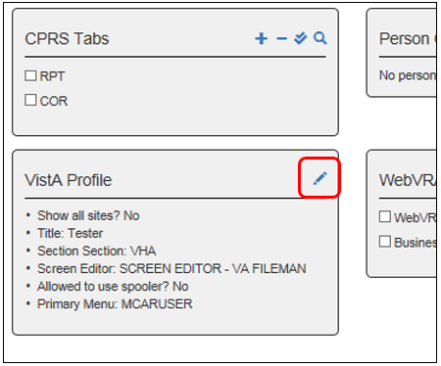

Figure : VistA Profile Data Entry Fields

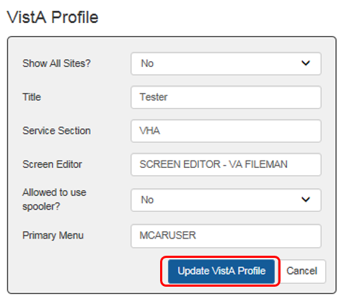

## Quick Delete of User Profile Entries

If a user profile data element needs to be deleted, return to the View/Edit User screen. For all categories of the user data except VistA Profile, hover the cursor over the item to be deleted and a trashcan icon will appear. Click the **trashcan icon**, and the element is deleted from the user’s profile. There is no need to open or edit the category box. See Figure 18 below.

Figure : Edit User Quick Delete Option

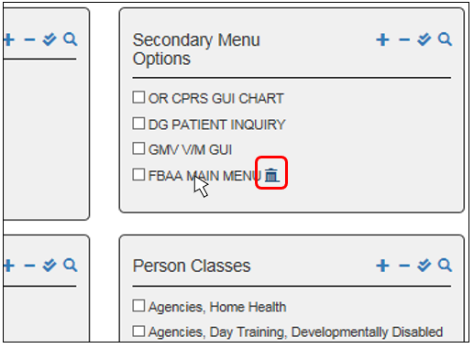

## Duplicate Users in Home VistA

If a WebVRAM Adminstrator attempts to add a new user to the WUT through the WAM, and that user has a nearly identical profile to a user who already has a profile in the VistA system that is the “Home” local VistA system to be added to the user, the following error will display as shown in Figure 19: “Cannot add user. There are two users with the exact same name on the Home VistA system. The user will need to request an account by visiting the [WebVRAM Access Request URL](https://webvram.va.gov/#!/requestAccess).”

Figure : Duplicate User Error Message

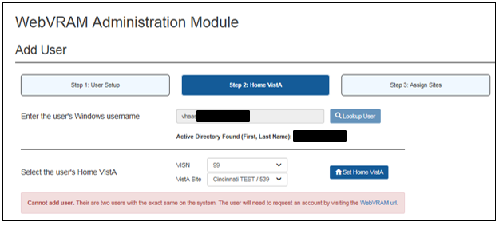

1. Contact the user and instruct them to navigate to the URL above using the Internet Explorer browser. Once the user has accessed this URL, they will need to complete the fields on that web page as shown below in Figure 20:
   1. Select the correct **Business Unit** from the drop-down list.
   2. Select the correct **VISN** from the drop-down list.
   3. Select the local or **Home VistA** from the drop-down list.
   4. Enter the Access and Verify codes used to access your Home (local) VistA system.
   5. Click **Send Access Request**.

Figure : WebVRAM Access Request Screen

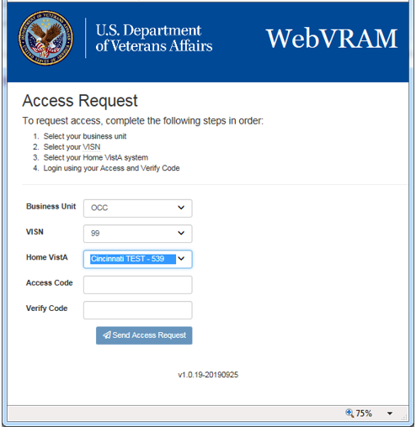

1. Once the user has successfully navigated to the page, entered all required information, and successfully sent the access request with no errors, login to the WebVRAM application and click on the **Manage**option on the toolbar. Select the user from the ***Last 10 Users Created*** or the ***Last 10 Users to Login*** or locate the user by entering the user’s name in the search bar on the first page of the user list.
2. When the user is located and displayed for editing, the user’s listing should show a ***Status*** of “Disabled” as shown below. Click on the **View User** button on the right side of the user listing. A user profile page will appear.

Figure : User Disabled Status

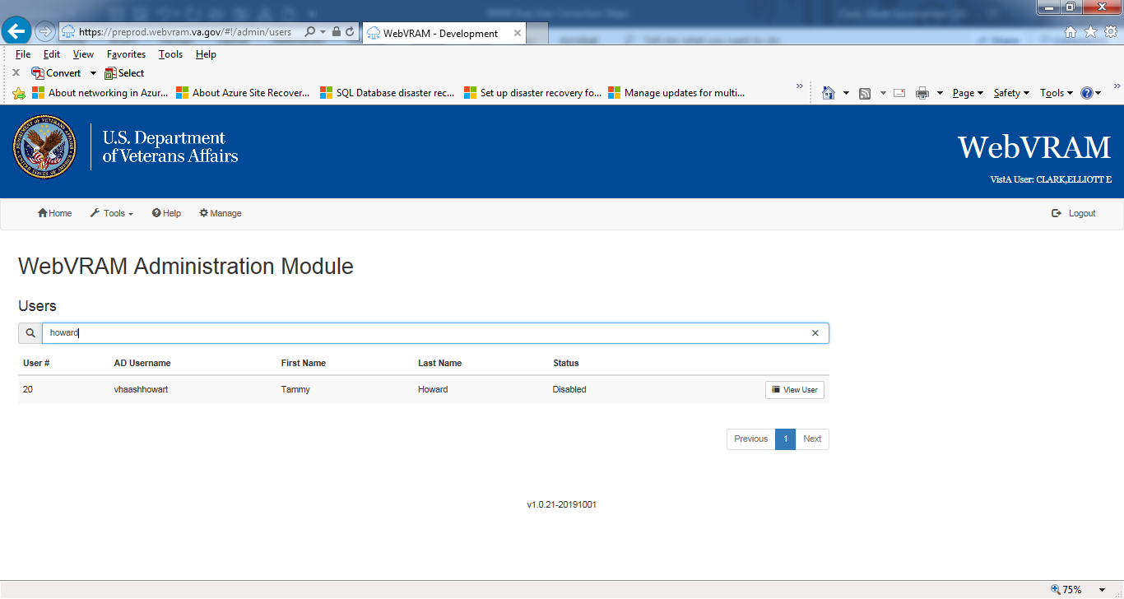

1. Click on the **Enable User** button on the top right of the user profile page, as shown below.

Figure : WebVRAM User Screen with Enable User Button

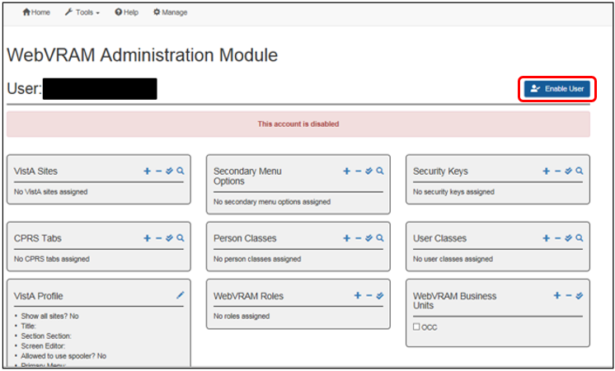

1. The button on the top right of the page changes from **Enable User** to **Disable User**. The user is now enabled for WebVRAM access. Contact the user with instructions to retry logging into the application. If they are unable to log in after these actions have been taken, ask the user to create a ticket using SNOW/YourIT or by calling the ESD directly.

## Viewing/Editing User’s Home VistA System/Name

To view a user’s Home VistA System setting, or to change the Home VistA System assignment in cases of the user relocating to another medical center, health care system, or VA office, perform the steps outlined here.

1. On the toolbar, click **Manage**. Select a user from one of the “most recent” lists, or if the user is not listed, click **Users** on the left side of the screen, then search for the desired user as shown in Figure 5: WebVRAM Administration Module Users Page.
2. From the user’s data overview screen, click **Edit User**, as shown below.

Figure : WebVRAM Edit User Screen – Edit User Option

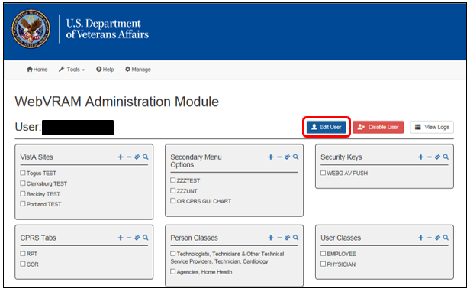

1. A new page appears with the user’s key data. In the “Home VistA” edit box, click the “**X**” to in the right side of the box, then type a few characters of the new Home VistA system into the box, as shown below.

Figure : User Key Data Edit Page

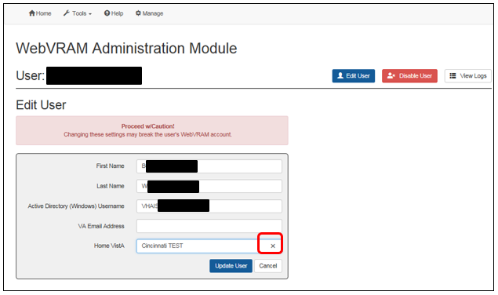

Figure : User Key Data Page – Home VistA Box Cleared

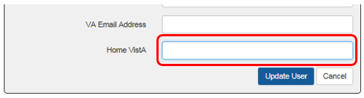

1. Figure 26 displays the auto-fill feature for the Home VistA box, which provides options for the new Home VistA system until the correct option is displayed in a text box below the Home VistA box. Type a ***partial name***of the desired new Home VistA system. In the example below, typing “min” brings up the **Minneapolis TEST** option, which can be added to the Home VistA field. Clicking on the option box presented with the correct full name of the VistA site to be added will populate the Home VistA field with that information, as shown in Figure 27.

Figure : User Key Data Page – Home VistA “Auto-Fill” Feature

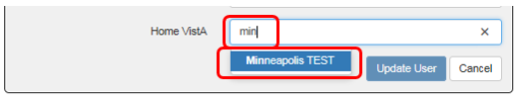

Figure : User Key Data Page –New Home VistA System Selected

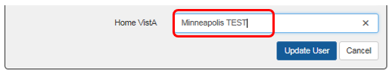

1. If the user has experienced a recent name change, the user’s name and VA Active Directory Username (Windows VA Username/Network ID) can also be changed in the **Edit User** component of their profile.

## View User’s Log

A log of the user’s activity on the system can be viewed from the WAM by clicking on the **View Logs** button at the top right of the User Edit Screen.

Figure : User Edit Screen – View Logs Button

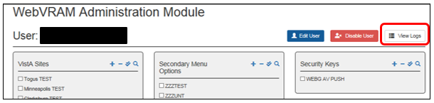

A listing of the user’s activity is presented, and the details of each user transaction can be viewed by clicking the **View Details** button to the right of each transaction entry. Figure 29 provides an overview of the user log and the **View Details** button.

Figure : User Log Listing

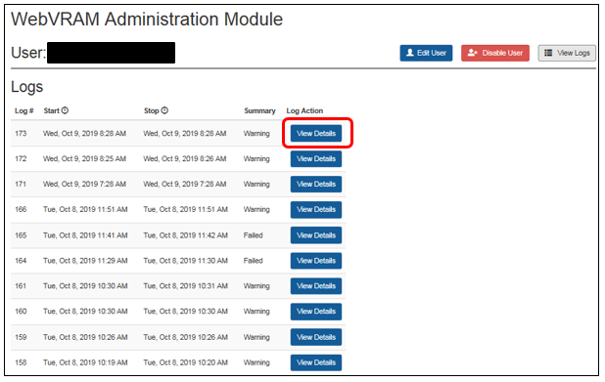

The figure below provides an example of the user transaction activity details, as captured in this log.

Figure : User Log Detail Listing

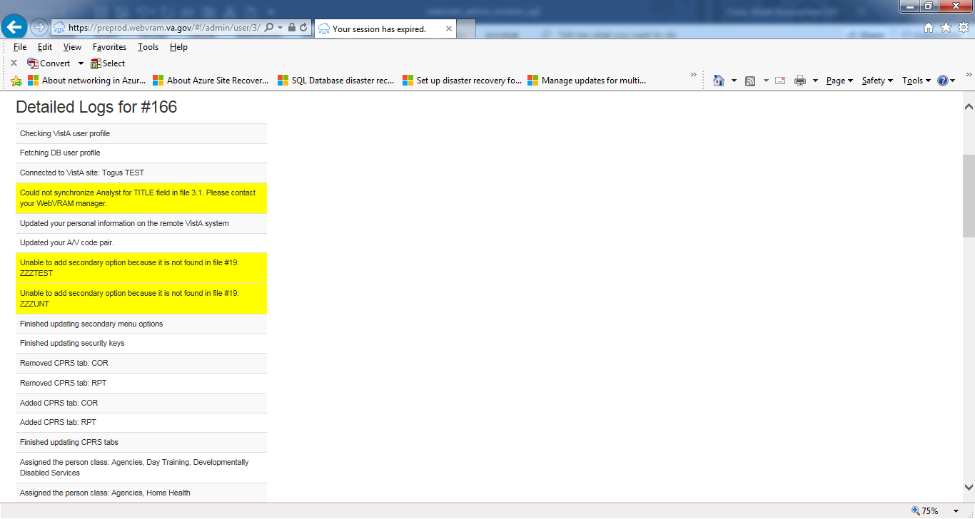

## Disabling User Account

When a user is transferred to another business unit and changes job duties that no longer require the use of WebVRAM to perform those duties, or when a user leaves VA, their WebVRAM profile must be disabled by the Business Unit Administrator. This is done by navigating to the **Edit User Screen** and clicking the **Disable User** button above the user profile summary, as shown in Figure 31 below. Once this is done, the **Edit User** summary screen will only show one button, **Enable User**, as shown in Figure 22, and the user will not be able to login to WebVRAM.

Caution symbol**CAUTION: Each business unit is responsible for working with local IT support to disable the remote site VistA system account(s) the user has established through the use of WebVRAM.** Remote site VistA user profiles established electronically through WebVRAM have a set expiration of 30 days; the remote site VistA user profile will expire if the user does not access or login to that remote site within that timeframe. If the VistA user profile established at a remote site through WebVRAM is active when the user’s WebVRAM profile is disabled, then the VistA user profile needs to have the disusered flag turned “on” at each remote site where the user is no longer authorized to access VistA.

Figure : Edit User Screen – Disable User Button

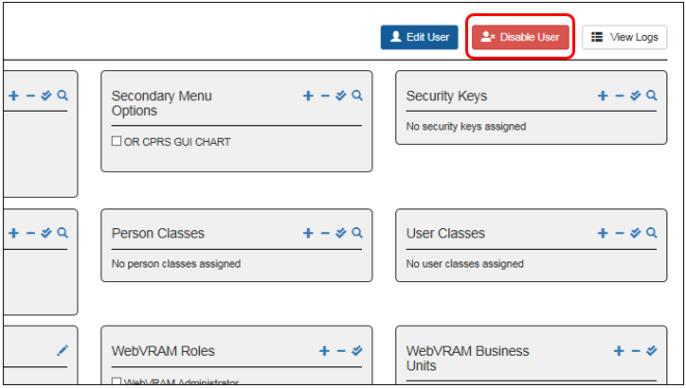

## Exit System

When you are finished with the work you need to perform, click **Logout** in the upper right corner of the page.

# Troubleshooting

For troubleshooting, please contact the Enterprise Service Desk (ESD) at 1-855-673-4357 for Tier 1-3 support.

## Special Instructions for Error Correction

For special instructions for error correction, please contact the ESD at 1-855-673-4357 for Tier 1-3 support.

# Acronyms and Abbreviations

Acronyms and definitions are provided throughout the document with first use. Commonly used project acronyms are also collected in the table below.

Table 3: Acronyms and Abbreviations

| Term | Definition |
| --- | --- |
| AD | Active Directory |
| CPAC | Consolidated Patient Account Center |
| CPRS | Computerized Patient Record System |
| ESD | Enterprise Service Desk |
| FBCS | Fee Basis Claim System |
| FPO | Field Program Office |
| GAL | Global Address List |
| GUI | Graphical User Interface |
| IAM | Identify and Access Management |
| NPI | National Provider Identifier |
| OIT | Office of Information and Technology |
| PII | Personally Identifiable Information |
| RPC | Remote Procedure Call |
| SDD | System Design Document |
| SNOW | Service Now, also called YourIT |
| SQL | Structured Query Language |
| SSO | Single Sign On |
| STIC | Station ID Callback Module |
| URL | Uniform Resource Locator |
| VHA | Veterans Health Administration |
| VM | Virtual Machine |
| VPN | Virtual Private Network |
| VRAM | VistA Remote Access Management |
| WAM | WebVRAM Administration Module |
| WebVRAM | Web VistA Remote Access Management |
| WUT | WebVRAM User Table |